Moultonboro Snowmobile Club
PO Box 118 - Moultonboro, NH 03254
www.moultonboroSMC.org
January 2010 Newsletter
February 6th Dinner Meeting
The Bob House on Route 25, Moultonboro
Social, Cash Bar & Appetizers: 6:00PM Dinner: 7:00PM
Each monthly dinner will consist of: 2 Appetizers, Salad, Homemade Rolls, 2 Dinner Entres, Vegetable, Homemade Dessert, Coffee, Tea or Soda, Tax & Tip Included.
Menu: Stuffed Meatloaf, Chicken Kiev, Baked Potato and Green Beans. Dessert to be announced, $17.50 each
Please make checks out to Moultonboro Snowmobile Club.
Please call for reservations to Cheryl Higgins at 253-4372 or e-mail at winnfabric@roadrunner.com
Check our website for details www.moultonborosmc.org
You’re a Winner!
Congratulations to long time Club member Jim Anderson. Jim purchased the WINNING ticket in the Maine Snowmobile Association Supper Raffle. The prize, a brand new 2009 Polaris 550 IQ Shift.

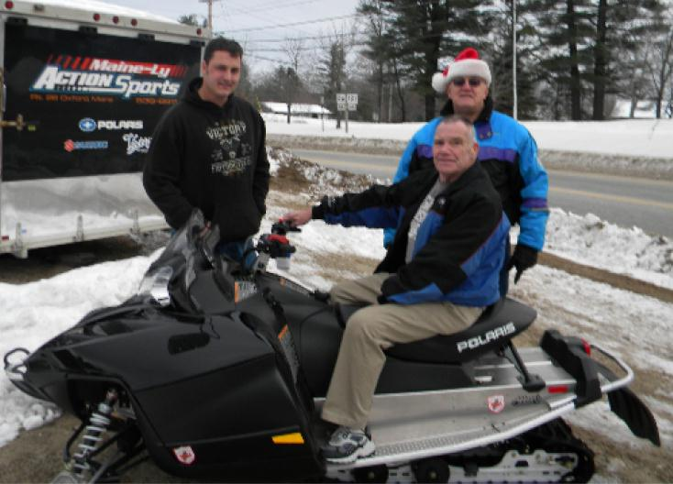
CLUB BONFIRE February 13th from 6 to 8 pm
Located at the CONLEY/DORVAL'S Residence (Gilman Point) Green's Basin-Winni.
Take Putman trail to Green's Basin Spur Trail (Watch for signs). Once you hit Winni head left (approx 10 o'clock) you will see the fire. Enjoy great food/hot beverages along with camaraderie with club members. No alcohol allowed!!
RSVP by Feb. 6 To JOEQUARESIMA@AOL.COM OR CALL 603 253 9322
PROGRESSIVE SUPPER February 20th
Appetizers at the Nerney’s at Hetherwood Estates.
Dinner at the Lions Club- probably Italian.
Dessert at Brian Hall’s in Far Echo Harbor Club
Need a place to stay?
Special Offer from the Roadway Inn. Local snowmobile club members get 20% off, visitors get 10% off. 603-253-3414

Below is the link to the NH Bureau of Trails Bi –Weekly State Trails Report
http://www.nhtrails.org/trail-uses/snowmobiling/snowmobile-trails-conditions.aspx
Saturday Rides
Vic & Steve will leave the Village Kitchen after breakfast every Saturday trail conditions allow. They usually stop for a quick lunch and return by 5PM.
There will be two large rides: one to Gorham via Trail 19 returning by Lincoln, NH. One to Bethlehem, then Littleton for lunch & returning Trail 5 to Rumney & home via rail bed, Another will be around the lake via Wakefield, New Durham & Gilford
Club Slow Rides (waiting for Snow)
We will be scheduling several Club rides for those not that familiar with our local trails. These rides will be at a leisurely pace.
Check out our Website for the latest information on Club Events and Trail Conditions. www.moultonborosmc.org
Here are some links to several local Snowmobiling Forums:
Winnipesaukee Forum
http://www.winnipesaukee.com/forums/
SledNH
http://www.slednh.com/forums/index.php?s=0f6717c2176c6649975facf68e91363b&act=idx
NHSA HOT NEWS PAGE
http://www.nhsa.com/news1.shtmlSee you on the Trails, George

